**Functions (SQL and PL/SQL)**

Today we are discussing about Functions in Oracle below is the diagram illustrate its types

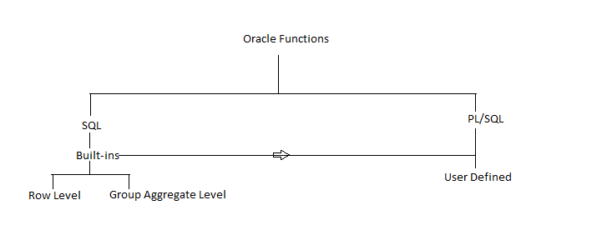

* Functions used in SQL and PL/SQL
* In SQL there are built-ins function for row and group level.
* In PL/SQL there are user defined functions with utilization of SQL built-ins where necessary.
* User defined can be called on run time SQL statement same like built-ins used.

Below are the categories of Row Level functions:-

* Character
* Number
* Date
* Aggregation

You will find out details for the same in Oracle Tutorial for SQL

**PL/SQL Function**

Now let consider about PL/SQL user defined Functions, if there are already built-ins then why we use user defined. The simple answer is built-ins does not cover all the needs of an organization to fulfill the needs of business process user define are required. In user defined functions if not anonymous can be called anytime in SQL queries.